Signature Block Example
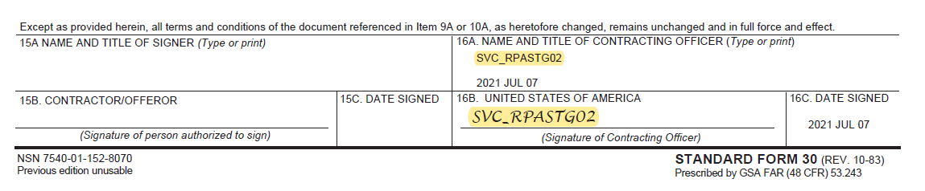
Second Page Authority Example
